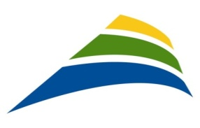

***Overall English-speaking population in the East Island of Montreal***

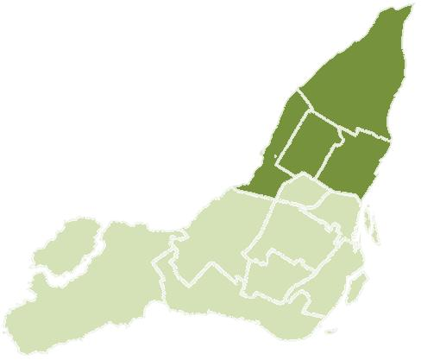

**CSSS de la Pointe de l’Île**

FOLS English 27 823

Total population 190 315

% FOLS English 14,6

**CSSS Lucille-Teasdale**

FOLS English 15 020

Total population 169 475

% FOLS English 8,9

**CSSS de Saint-Léonard et Saint-Michel**

FOLS English 31 745

Total population 128 465

% FOLS English 24,7

**CSSS d’Ahuntsic et Montréal-Nord**

FOLS English 21 023

Total population 157 325

% FOLS English 13,4

Legend:

*FOLS English*: population belonging to the CSSS whose

first official language spoken is English

*Total population*: Total population of the CSSS

*% FOLS English*: Percentage of population living

in the CSSS whose first official language spoken is English

Source: Community Health and Social Services Network (CHSSN)/Pocock ,J. (2014) *Baseline Data Report 2013-2014* *Demographic Profiles of the English-speaking Communities of selected CSSS and CLSC Territories.* Based on the 2011 National Household Survey. [www.chssn.org](http://www.chssn.org)