2015-2016

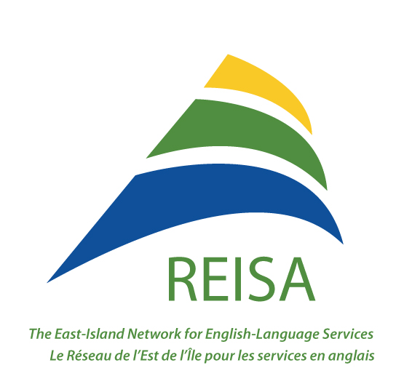

Annual Report | The East Island Network for English Language Services

Table of Contents

President's Message 3
Board of Directors and Staff 8
REISA Celebrates 10 Years 10
Governance and Administration 11
Partnerships and Collaboration with the CIUSSS 11
Adaptation of Health and Social Services 12
Partnership with Educational Institutions 12
Community Networking and Representation 13
Knowledge Development 14
Health Promotion 15
McGill Training and Retention of Health Professionals 16

President's Message

The past year has been another busy and productive year for REISA. The following report outlines the programs and activities REISA has been involved with in Montreal’s East-end communities, including the promotion of programs dedicated to both the youth and seniors, networking and support to partners.
The highlights of the year have been the Liaison pilot project carried out with the CIUSSS de l'Est-de-l'Ile de Montréal under the Adaptation of health and social services initiative and the expansion of the McGill Retention of Health professionals.
REISA’s financial reality also means that we have to be strategic and careful in the way we deploy our resources. There are many good causes and the temptation to respond to them all is big; however, we need to set clear priorities and zero in on those that are more urgent and/or more likely to have a significant impact. I see these two issues as the main challenge for the coming year.
REISA is lucky to have a competent and dedicated staff; led by Fatiha Gatre Guemiri and assisted by Robyn Graham, Claudia Maiolo, Juliana Zappitelli and Djahida El-Krarraz as well as Ghislaine Prata’s invaluable consult.
However, the small team can hardly respond alone to the most burning issues, let alone to all the rest. To strengthen our impact for the benefit of the East-end English-speaking community, we need to explore how we could possibly enhance member participation.

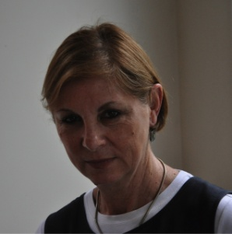
Ella Amir
President of the Board of Directors

Minutes of the

Annual General Meeting of

The East Island Network for English Language Services (REISA)

at the Leonardo Da Vinci Centre, Galleria, 2nd floor

On Wednesday, June 17, 2015

At 9:35am

Opening of the Annual General Meeting
Ella Amir initiated the meeting by introducing herself and asked the rest of the attendees to introduce themselves.
Announcement that 2015 is the 10th anniversary of REISA. This is a special AGM for REISA.

Appointment of the Chairperson and the Secretary of the meeting
Ella Amir is appointed the Chairperson; Robyn Graham is appointed Secretary of the meeting.
Howard Nadler moved to accept the Chairperson and the Secretary, seconded by Giovanna Colasurdo and unanimously approved.

Approval of the minutes of the Annual General Meeting of June 18, 2014
Ella Amir invited participants to read the minutes;
There was a change on the third page, ninth paragraph. Josie Primiani moved to accept the minutes of June 18, 2014, seconded by Dorothy Williams and unanimously approved.

Acceptance of the Annual Financial Statements (Avis au Lecteur) for the financial year ending March 31, 2015
The Treasurer gave details of the Annual Financial Statements. All of REISA's funding comes from one funder, the CHSSN.
The biggest expense is salaries and professional fees. The other major expenses were for rent, and meetings/travel.
There was a deficit of $9,896 which balanced the budget of last year and this year there is a surplus of $12,143.
The fund balance this year is $27,259, over $15,116 from last year.
REISA requires an audit this year as per the request of CHSSN.
Howard Nadler moved to approve the financial statements; Maria Maiolo seconded and unanimously approved.

Appointment of Auditor for the current financial year
Howard Nadler moved to retain Chapman and Chapman as our chartered accountants and as auditors; Dominic D’Abate seconded and unanimously approved.

Presentation of the activity report for year ending March 31, 2015
The Executive Director presented a picture slideshow of the successes of 2014-2015. An homage was given to Janet Forsyth, co-founder of REISA, at the beginning of the slideshow. Two staff members had babies in 2014-2015, whose pictures were also shared at the beginning of the slideshow. The annual report was printed and handed out to the attendees with the highlights and difficulties of the year.
The Executive Director went through the history of REISA and its funders for the purpose of the ten year anniversary.
REISA's current funder is Health Canada. Attempts to obtain funds from Canadian Heritage have failed due to the fact that REISA does not offer direct services to individuals in the ESP community.

Network membership: the founding members of REISA are the same as the REISA Board members. Throughout the year, the Board look at ways of diversifying its membership. Currently REISA is working well, however, change will be happening. The following questions were asked: Is it necessary to restructure REISA? Do we need a new vision?

Montreal North was REISA's primary area of interest due to new immigration. REISA is now an official member of the Table de Concertation des ainés de Montréal-Nord.

Success: The increase in of representation for REISA at various institutions is an indication that we are recognized as the only advocate for the English-speaking population in the East.
New membership with Vivre Saint-Michel en Santé and the Table de Concertation de Montréal-Nord. Calls are received from all sectors of Montreal to REISA for information on services in English.

Liaison project: Three years ago REISA presented the liaison project to the Agence where it was initially accepted to cater to the needs of the English-speaking population in the four CSSS territories in the East. The project was submitted to the Agence in November and was rejected. After a long process of negotiation, the project was finally accepted for 15 months. The scope of the project was reduced from all four CSSS to only one CLSC. Researcher, Mylene Kosseim, and Liaison Agent, Djahida El Krarraz, were hired for this project. The initial stages of the project have been successful.

Reorganization of the Health sector: As of April 1, three out of the four CSSS that REISA works with have been integrated into the CIUSSS de l'est-de-l'ile de Montreal and the other CSSS to the CIUSSS du Nord-de-l'ile de Montreal.
CIUSSS nominations: candidates from REISA's board of Directors (Dominic D'Abate, Theo Vecera, Josie Primiani) were submitted for the CIUSSS Board of Directors. Ghislaine Prata, REISA's consultant, was also nominated.
REISA has demographic data and statistics from CHSSN that we have used to make our own documents for distribution. We have given this data to the CSSS' and to community organizations to show the needs for English services, particularly for seniors.

Visibility of REISA: According to our yearly website report, REISA's page views have doubled monthly since last year. The most viewed pages are Emergency temporary housing; Physical and or mental disabilities; Legal aid and information. Most of the questions received via email to the “info” address were regarding employment or internship opportunities.

Mental health - Équipe Quartier- a group of street walking health professionals in Montreal North, indicated that mental health issues are acute. A meeting was held with the DG of the CSSS Montréal-Nord to discuss the problems that were brought up in a previous meeting that REISA had with two workers from Équipe Quartier. We must wait for new structure in order to set-up new meetings.

Community Network Forum: This year' s Forum was a huge success. Projects from REISA, Batshaw/ACDPN, AMI-Québec/Cummings Seniors Center/ YES Montreal, were presented. There were 52 people in attendance which was a great networking opportunity for all. REISA was mentioned in EMSB Connections newsletter along with the success of the forum. The forum report will be on REISA’s website. REISA is committed to the English-speaking population in the East end.

McGill Retention project: Juliana Zappitelli, REISA’s new Communications and Programs Agent, is one of REISA’s success stories. She worked as an intern for the Centre for Dreams and Hopes and is now a graduate from McGill and works for REISA. She is in the process of producing promotional material to attract students to the East end. The need has increased this year for interns and she is developing partnerships with various Universities and colleges to promote internships in the community.

Photos from the Glee Club drama therapy group were shown as a success story. Jennifer Furlong was funded by REISA for 8 weeks of Drama Therapy at the Centre for Dreams and Hopes. Permanent funding is being sought out for this project.

Celebrating 10 years
Jim Carter congratulated Fatiha Gatre-Guemiri on ten years of hard work. He proceeded to speak about REISA’s meagre beginnings and the difficulties that were had: ''Ten years ago, the English-speaking community in the East Island was so overwhelmed and there was so much need for services. The initial project from CCS was called Cultivating Roots and it was an initiative to increase access to health and social services in the East end. The early actions were really that of understanding and reconnecting with the roots of the English-speaking groups of the East Island, and community organizing.
This is an important story for inspiration to other communities. REISA is a veteran to demonstrate the mobilization of a community network. ''

The REISA team asked Howard Nadler to present a Certificate of Recognition for ten years of developing and supporting the health and well-being of the English-speaking population to Fatiha Gatre-Guemiri. He gave a beautiful speech detailing the day he met Fatiha and how'' he found her very interesting, educated and committed to multiculturalism and that this award is a testament to her creativity, her warmth and her strategic way of looking at things that contributed to the growth of the organization''
Janet Forsyth (Absent) was also awarded a certificate of appreciation that will be delivered to her by the Executive Director.

Fatiha Gatre-Guemiri thanked the networks who support REISA and said a special thank you to Robyn Graham-Johnson for offering her services in a time of need; Jim Carter for all of his support over the years; Dora Cesta for all of her advice; Dominic D’Abate for his support; Ella Amir for her expertise; Ghislaine Prata for all of her support and expertise and being the consultant to REISA; Fred Jansen for rekindling the partnership between CCS and REISA; Maria Maiolo and the Servizi for their ongoing support and their initial sponsorship of REISA.
Ella Amir commended Fatiha Gatre Guemiri for her leadership and for her hard work that got REISA through hard times.
Dorothy Williams thanked REISA for the support to BCRC and Dominic D’Abate for maintaining a sense of family to the Network.
Board election
Dora Cesta announced that she will be stepping down as board member to REISA. Unfortunately she is too busy this year with all of the changes happening at the EMSB and will not be nominating another member from the EMSB to replace her at this time.
Howard Nadler is remaining Treasurer of REISA for this year, however, he will be retiring from Batshaw at the end of the fiscal year and will no longer be able to represent Batshaw on the REISA board.
Josie Primiani moved to accept the re-election of the rest of the Board members as is for 2015-2016, seconded by Theo Vecera and unanimously approved.
It was noted to keep a connection with the EMSB and to Batshaw throughout all of the changes that are about to happen. Jim Carter also noted that networks are experiencing a tsunami of institutional reform. A lot of disruption of relationships is happening. Support for REISA must continue throughout the reform. Being that REISA is a pillar in the community, it will not fall apart because of these changes. REISA is the connection with the community and it will always be there. The needs are still there and REISA offers continuity and constancy in this time of turbulence. REISA will look upon other networks for support as well.

Question and Answer period (Varia)
Ella Amir highlighted that AMI-Québec recognised Colin Coole, from the Assistance and Referral Centre, and gave him the “Extra mile” award. AMI-Québec also recognised Jim Carter and he was awarded the “Exemplary Service in Mental Health” award.
Dominic D’Abate gave thanks to the Executive Committee for their hard work on behalf of the Board of Directors.

Closing of the Annual General Meeting
Ella Amir thanked everyone for their participation.
The Annual General meeting was adjourned at 11 a.m.

Board of Directors and Staff

Board of Directors Organisation
Amir, Ella - President AMI-Québec
Colasurdo, Giovanna Almage Senior Community Centre
D’Abate, Dominic Consensus Mediation
Gagnon, David-Roger English Montreal School Board
Maiolo, Maria Italian-Canadian Community Services of Québec Inc.
Marsillo, Joe - Vice-President Toxico-Stop
Nadler, Howard - Secretary and Treasurer Batshaw Youth and Family Centre
Seales, Sean Black Community Resource Centre
Primiani, Josephine East Foundation, Centre for Dreams and Hopes
Vecera, Theo Don Bosco Youth Leadership Centre
Modifications to the Board of Directors
Dora Cesta, representing the English Montreal School Board, stepped down as board member, however, the Agent Pivot, David-Roger Gagnon replaced her at following meetings. Howard Nadler, Treasurer and Secretary, retired from Batshaw Youth and Family Services as of March 31. He agreed to fulfill his term until the end of 2015-2016 and another representative from Batshaw was proposed to take his place as a board member. Dorothy Williams, representing the Black Community Resource Centre, proposed another representative, Sean Seales to fulfill her term due to her departure from the organization in the fall.

Staff Title
Gatre Guemiri, Fatiha Executive Director, NPI Coordinator
El Krarraaz, Djahida Adaptation Pilot Project Liaison Agent
Graham-Johnson, Robyn Communications/Coordinator
Maiolo, Claudia Communications/Coordinator
Zappitelli, Juliana Project Agent - McGill Retention of Health Professionals
Prata, Ghislaine Consultant - Advisor
Kosseim, Mylène Consultant Adaptation Pilot Project - Liaison

REISA Celebrates 10 Years

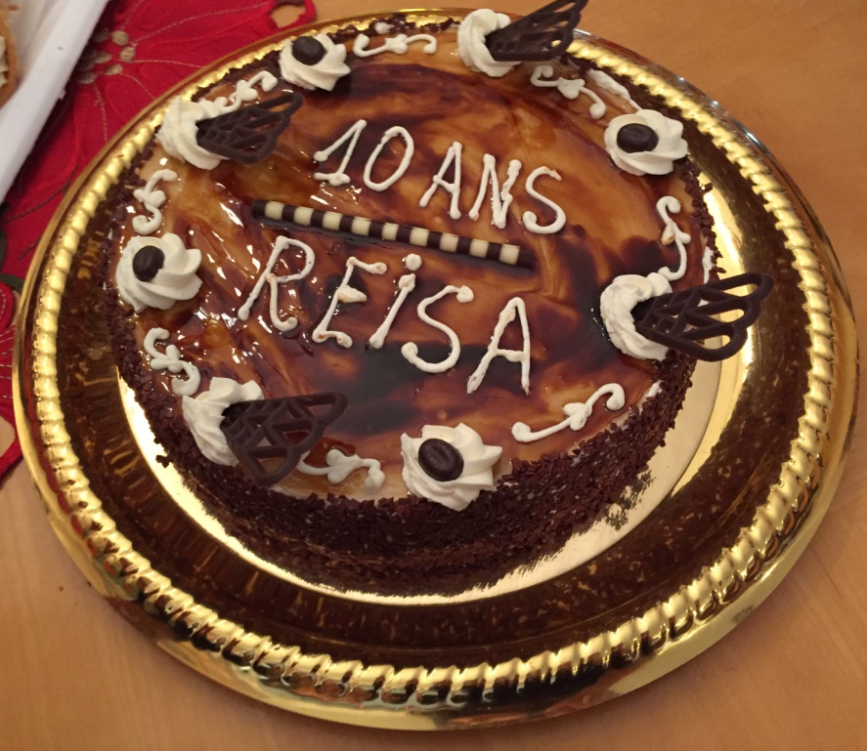
2015 marked 10 years of existence for REISA and was celebrated during the AGM with partners. The Executive Director, Fatiha Gatre-Guemiri, was awarded with a Certificate of Recognition for ten years of developing and supporting the health and well-being of the English-speaking community. Janet Forsyth, who contributed greatly to REISA's success as an organization, was also awarded a certificate of appreciation.

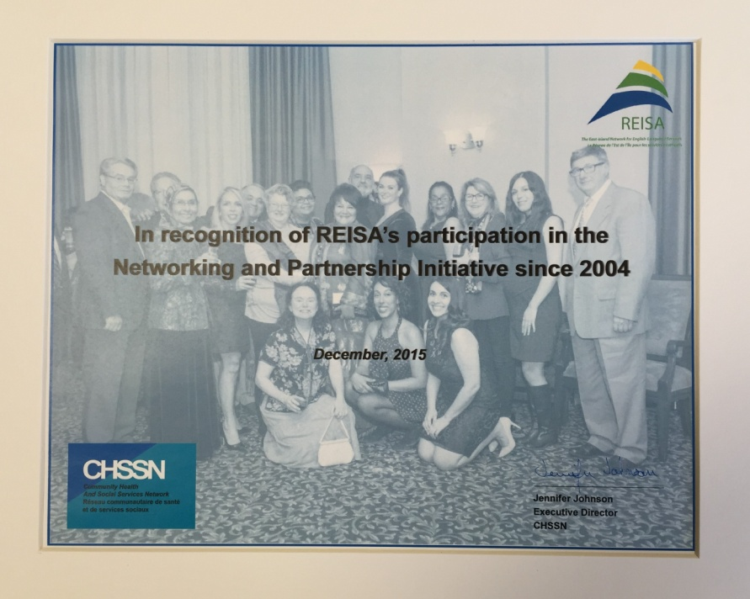

A formal recognition from the CHSSN for REISA's participation in the Networking and Partnership Initiative since its creation, was presented to the organization by Jim Carter at the December 15 board meeting.

Governance and Administration

Board, Executive and Network meetings
REISA held three board meetings, six network meetings and several AD-Hoc executive meetings throughout the year. In January, board and network meetings were combined to reduce the number of meetings. The Annual General Meeting was held on June 17th, 2015. 21 people were in attendance.
Board Membership
The Executive Committee reviewed the board membership section in the by-laws in January. Proposals were discussed at the January board meeting and the following amendments were made:
On January 27, it was decided to extend membership to individuals. A motion was adopted in April to amend Article 2.1.1 of the Bylaw from :

a) is a public or para-governmental agency or a non-profit community organisation;
c) is located in the territory of the Association as defined in article 1.3 of these by-laws or serves a population residing in the aforementioned territory

to:
a) is a public or para-government agency or a non-profit community organisation; and individuals.
c) is located in the territory of the Association as defined in article 1.3 of these by-laws or has expertise
in serving the aforementioned territory.

Reports and Applications for funding 2016-2018

- Two annual reports for each program carried out in 2015-2016.
- Performance evaluation reports for each program of 2015-2016.
- Applications for 2 year funding (2016-2018) of HPP, NPI, McGill Retention, McGill Golden Share.
- Punctual projects carried out with surplus funds obtained from the CHSSN in January.
- Application for the Canada 150 fund in partnership with the Centre for Hopes and Dreams.
- Planning and development of new health promotion projects for seniors, families and youth.

Partnerships and Collaboration with the CIUSSS

- Contacts were made early in the time of restructuring of the new CIUSSS'. REISA obtained the organizational charts in order to identify the partners according to identified needs.

- Meeting with the respondent for access to English services of the CIUSSS du Nord. The priorities identified for English-speaking seniors and youth with special needs in Montreal North were presented to him; a request was made for regular visits to the Centre for Dreams and Hopes and the Almage Satellite group by a social worker and a nurse from the CIUSSS; we were assured of a collaboration and follow-up with the SAPA and youth services directors.

- Meeting with the DG of CIUSSS du Nord in February who assured us of a full collaboration.

- Several meetings for the launch and Coordination of the Liaison pilot project from March 2015 until May 2016 with the SAPA director and assistant director.

- The successful collaboration with the two CIUSSS's was demonstrated by the participation of the DGA of Montreal North and two assistant directors of East Montreal at the Community Forum in March 2016 and the provision of support letters to REISA initiatives.

Adaptation of Health and Social Services

Objectives of the Pilot project -CLSC-Mercier-Est-Anjou - REISA - Almage partnership
- Provide a better access to front-line health services expertise for English-speaking vulnerable seniors in Montreal’s East-end;
- Support the CLSC Mercier-Est-Anjou in identifying and implementing arrangements for linguistic accessibility addressing the needs of seniors on their territory;
- Support the CLSC to provide better reception and intake services for English-speaking clients based on needs identified;
- Promote knowledge of access mechanisms to health and primary social services and to community support services available to English-speaking seniors in Montreal East;
- A steering committee was formed by the REISA team, a consultant researcher and a liaison agent hired by REISA and the CIUSSS directors of services to seniors SAPA and the assistant director to Home support services (SAD);
- The consultant's mandate was to develop a logic model, conduct surveys on seniors needs in collaboration with the Almage seniors centre and produce an evaluation;
- The outcomes of the projects were attained as planned: bilingual professionals were identified, documents used by health professionals were translated, liaison between the team of Soins à Domicile and Almage was established, the trajectory of request for services was identified and documented;
- An evaluation of the process was conducted by the researcher and a report was produced in May.

Partnership with Educational Institutions

McGill Retention Program

- In 2015-2016, field placement coordinators were contacted from educational institutions to promote East end internship opportunities and to create and maintain partnerships. We have partnered with the following institutions: McGill University, Concordia University, Vanier College, Dawson College and John Abbott College.
- Golden Share: REISA was invited to showcase the community initiatives in the development of internship sites within the East -end community groups and the opportunities offered to students. As a result funding was made available from McGill allowing us to maintain the coordination.
- Promotion of internships and careers in health and social services at the McGill School of Social Work career fair on March 11 and the Occupational Therapy and Speech, Language and Communication Disorders on March 14.

Community Networking and Representation

Local and Regional Representation

REISA team members participated in a variety of events and opportunities to represent the network of English-speaking organizations and to sensitise partners to the English-speaking community needs and priorities in the East-end:
- Regular meetings and AGM of : Concertation des Aînés de Montréal-Nord , Vivre Saint-Michel en Santé and Collectif Jeunesse; Concertation St Léonard;
- The Montérégie Health Fair;
- There were several NPI program training sessions, including the bi-annual CHSSN retreats and numerous conference calls throughout the year regarding new projects, funding and sharing of best practices with the other NPIs;
- The Center of Dreams and Hopes' Snoezelen Room Grand Opening on March 22, which will serve to provide individuals with developmental disabilities, such as Autism Spectrum Disorder, a therapeutic and stimulating environment during challenging times.

New Community Partner : Kahnawake Assisted Living Services (ALS)

REISA initiated a partnership between the Centre for Dreams and Hopes and Assisted Living Services, which is a community group for Mohawk youth with special needs in Kahnawake. A project was developed in the spirit of Reconciliation and titled: Seeds of Reconciliation - English and Mohawk youth with Special Needs Celebrate Canada 150. This will be a celebration of Canada's diverse communities with arts and the planting of maple trees by youth living with special needs from the English-speaking community of the East end of Montreal and the Mohawk community of Kahnawake.

Community Network Forum
Organisation of the 6th annual Community Network Forum held on March 30th and attended by 55 participants: This year's forum demonstrated community Models for Health Promotion and Public Partner Engagement, focused on community health promotion initiatives that mobilize communities and empower them to address health promotion and disease prevention.

Highlights from this forum were:
Share Fair: community organizations were invited to display and share information at a on their own health promotion programs
Discussion Panel : Batshaw Youth and Family Centres as well as CIUSSS representatives from across Montreal were present and joined in a panel discussion revealing the institutional perspectives on the role the community organizations are playing to support institutional mandates. The feedback from the forum was very positive and proved to be a great networking opportunity for all who attended.

Knowledge Development

Community Needs Assessment

A community needs assessment was carried out to document the reality of health and social services for youth and families with special needs in the East end of Montreal. Informal focus groups were organised with parents and caregivers of individuals with special needs in March. This a fundamental step to develop tools that address and better supports the intersectional challenges that these individuals and family systems endure. REISA will be producing a special needs resource guide for the ESP in the East end of Montreal.

Resources guides for services

REISA released two resource guides in 2015:
- Health and Social Service Resources for English-Speaking Communities in the East End of Montreal
- Health and Social Service Resources for the English-Speaking Seniors in the East End of Montreal
The two resource guides were shared with the CIUSSS de l'Est- de-l'île-de-Montréal and the CIUSSS du Nord-de-l'Ile-de-Montréal. They were disseminated on their intranet and can be downloaded by the public on the CIUSSS websites under the resources section.

Communications

- Updates on different events planned for 2015-2016 organized by partners across the island of Montreal, were posted on the REISA website.
- Partnership developed with COCo's IT department for the reconstruction of the website. The official launch of the new website will take place in 2016.
- A Facebook page was set up for weekly posts of pertinent information on health and social services for the community every week.
- Partner newsletters and communications are disseminated as well as pertinent information regarding potential project funding are distributed to the REISA network via email.
- CHEP videoconferences were featured in the Almage Senior Centre Newsletter
- Regular messages from REISA to the parents community in need of health and social services in English were featured in the LMAC CLC newsletters.

Health Passport - Montreal East

Through funding from the CHSSN, REISA adapted and produced the Health Passport and disseminated it to the East end community. The goal of this guide is to make it easier for an English-speaking person to communicate with French-speaking health professionals. The CHSSN designed a web application to keep track of essential health information and puts helpful words and phrases at your fingertips was adapted specifically for Montreal East and made available on REISA website.

Referral of services
Referrals for services are regularly offered by the REISA team to members of the community who have searched for English services on the internet and found REISA’s website, or were referred by the Network's public and community partners. Website visits are monitored every month and analysed at the end of the year through Google Analytics.

Health Promotion

Community Health Education Project (CHEP) Videoconferences

REISA hosted three videoconferencing sessions at the CLC Laurier MacDonald: Living with Stroke, Better Bowel Health and Memory Disorders. A DVD session was also organized at the Almage Senior Centre on Stroke-Brain Attack with resources from the Heart and Stroke Foundation. The videoconferences at the CLC are usually attended by a very small number of service providers and no seniors can attend due to the distance and transport challenges. The ideal situation would be to have a videoconference system at Almage.
Health Promotion Projects in Planning and Development
Youth Projects in Schools

House of Kings and Queens - a program developed by BCRC will be funded by REISA to be offered in some East end schools in 2016-2017. There are two components to the project: one with the main target being young males and the other being young females:
- House of Kings: A program designed to help young males become wholesome role models for their peers and communities. The “Kings” of each community uphold a set of values and exemplify what it means to be a role model.
- House of Queens: Derived from the successful Taking Hold project, this is designed to work with schools with “at-risk" girls. Facilitators design and run themed workshops on topics such as friendships, self-confidence, bullying, conflict resolution, team work, self-care, gangs, risky behaviour, and relationships.

After School programs

The Don Bosco Youth Leadership Centre offer after school youth programs vulnerable youth at risk from Inner city schools in Montreal North. The Girls Club a program aimed at building self esteem, reducing peer pressure and preventing drug addictions. is set to begin in October 2016 and will be supported by REISA.

Families in Transition - Building Lasting Co-Parenting Relationships

The Co-parenting information sessions that will address family composition and structure; parental conflicts; parents’ abilities to exercise their parental responsibilities from a couple to co-parents; and re-building lives .
The Co-Parenting sessions led by a Family Lawyer and a Mediator will start in September 2016.

McGill Training and Retention of Health Professionals

Community Internships in Health and Social Services

Through the McGill Retention Project, REISA is promoting careers in health and social services, with the intention of placing English-speaking interns in the East End with the purpose of Retention in the East end:

- Interviews have been held with interns placed in East End community organizations and on-site supervisors to better understand their field placement roles and responsibilities and promote to future placement candidates.
- Several documents have been created and disseminated, including a resource pamphlet promoting East End placements, a document describing East End community groups and their mission and a pamphlet highlighting the 43 careers in health and social services most in demand in Québec.
- Various departments and placement databases at educational institutions and the English Montreal School Board have been contacted and received all documents pertaining to the project and were disseminated to students at the McGill Social Work, Physical and Occupational Therapy and Speech, Language and Communication Disorders job promotion fairs.
2015-2016 community placements in the East End:
- 3 McGill School of Social Work students
- 9 McGill School of Dietetics and Human Nutrition students
- 1 Dawson College Social Services student
- 1 Vanier College Special Care Counselling Student

2016-2017 Planned East Island Field Placements:
- 2 McGill School of Occupational Therapy students
- 1 Concordia School of Public Affairs and Policy Studies student

McGill Golden Share Initiative

On November 18th, REISA was invited to participate and present in a Community Network Roundtable amongst various partners in the community and public sector organised by McGill University. The presentation focused on success stories, partnerships created through the project, fields of study and educational institutions involved, and community field placement locations in the East end of Montreal.
The REISA model of community placement was well received and considered a successful model that can be replicated. REISA was invited to apply for funding through the Golden Share Initiative and was awarded extra funds to ensure more resources to the program for the 2 years.

Thanks to our Network Partners and the CHSSN team
for their continued support.

